MOLECULAR VISUALIZER PRO

Project Overview
Molecular Visualizer Pro is an interactive 3D molecular viewer built using Python and the VPython library. The application fetches real molecular data from the PubChem REST API, renders atoms and bonds in a 3D scene, and provides an informational dashboard. Users can search any molecule by name, toggle vibration simulation, and inspect individual atoms via double-click labels.

Key Features
- Real-time 3D molecule rendering via VPython spheres and cylinders
- Live PubChem API integration — any molecule searchable by name
- Automatic bond detection based on inter-atomic distance threshold (< 1.6 A)
- Sinusoidal vibration simulation toggled via Vibrate/Pause button
- Double-click atom labelling — shows element symbol on selected atom
- Live Molecule Dashboard: formula, atom count, bonds, MW, dominant element

Demo Molecule: Camphor
The application was demonstrated using Camphor (C10H16O), a bicyclic monoterpenoid compound. Camphor is widely used in pharmaceuticals, cosmetics, and as an insect repellent. The following results were generated automatically by the application upon loading the molecule from PubChem.

MOLECULE DASHBOARD — Camphor
Name | Camphor
Molecular Formula | C10H16O
Atoms | 27
Bonds | 28
Unique Elements | 3
Composition | O: 1, C: 10, H: 16
Molecular Weight | 152.23 u
Dominant Element | H (Hydrogen)
Element Types | Oxygen (O), Carbon (C), Hydrogen (H)

Camphor with Atom Label

The screenshot below shows the rendered 3D ball-and-stick model of Camphor. The red sphere represents the single Oxygen atom (O), grey spheres represent Carbon atoms, and white spheres represent Hydrogen atoms. A double-click on the Oxygen atom produced the inline label visible in the image.
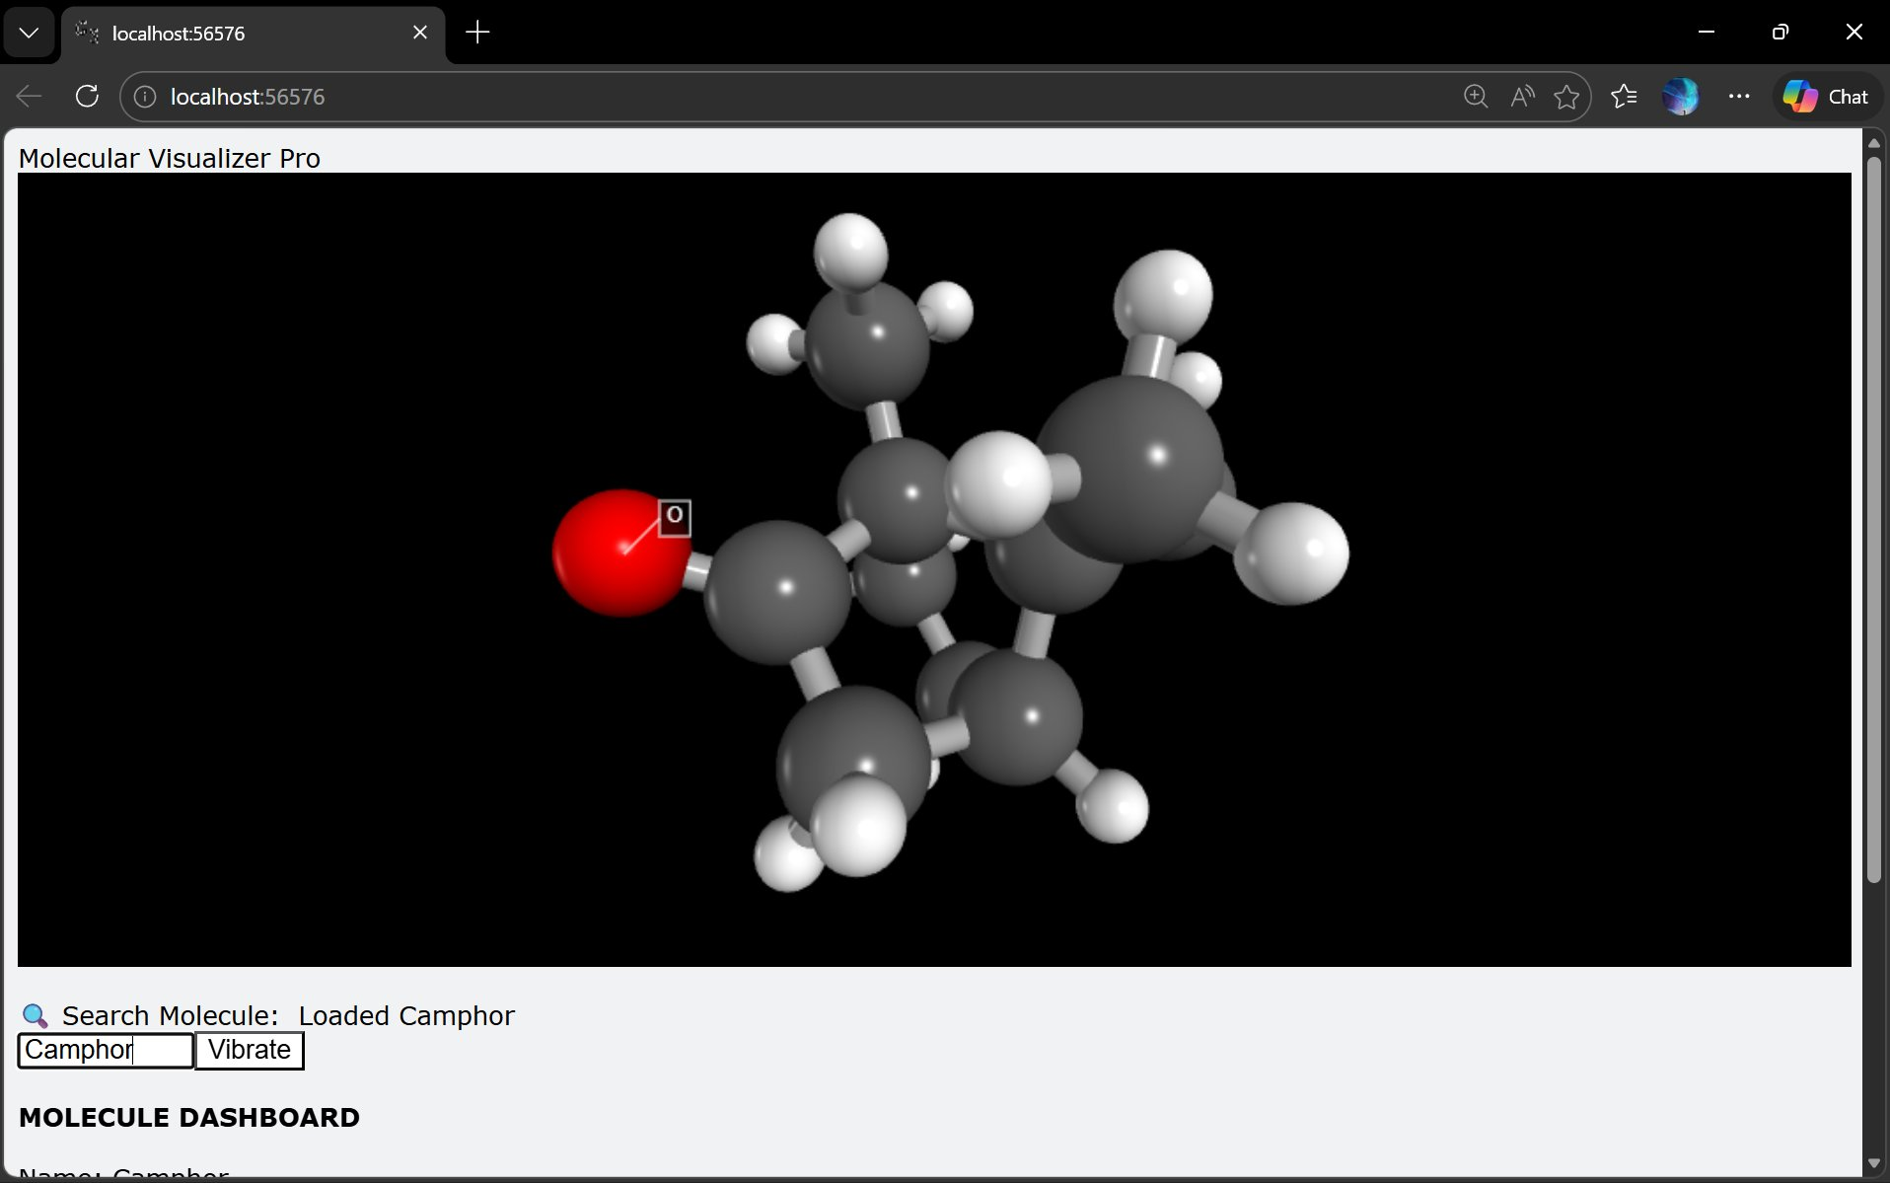
Figure 1: 3D view of Camphor with Oxygen atom labelled

Molecule Dashboard Output
The panel below shows the auto-generated dashboard displayed beneath the 3D canvas. All values are computed dynamically from the loaded XYZ coordinate data and the ATOMIC_WEIGHTS dictionary.

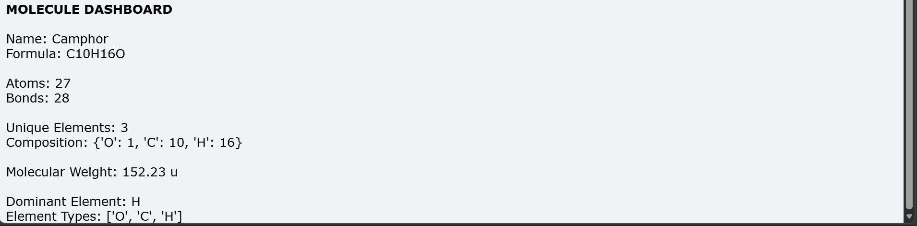
Figure 2: Molecule Dashboard showing stats for Camphor

Technical Architecture
Component | Details
Language | Python 3.x
Rendering Engine | VPython (Visual Python) — WebGL-based 3D canvas
Data Source | PubChem REST API (SDF 3D format)
Atom Parsing | XYZ coordinate extraction from SDF lines
Bond Detection | Euclidean distance threshold < 1.6 Angstrom
Simulation | Sinusoidal displacement along radial axis (f = 10 Hz, A = 0.05)
Interaction | Mouse click event binding for double-click atom labels
UI Controls | winput (search), wtext (dashboard), button (vibrate toggle)

Conclusion
Molecular Visualizer Pro successfully demonstrates a full-stack molecular simulation pipeline in Python. The integration with PubChem provides access to thousands of real compounds. The VPython rendering engine delivers interactive 3D visualization without requiring any external graphics framework. The application is well-suited for educational use in chemistry and biochemistry contexts, providing instant visual and quantitative feedback on molecular structure.

